Test Case: tc006_SPX_Dev5_Crear_Requisicion_Spot_Tipo_Cobro_Proyect_Urgent
Step 1 - Enter username and password and click to button Enter: Credentials Entered
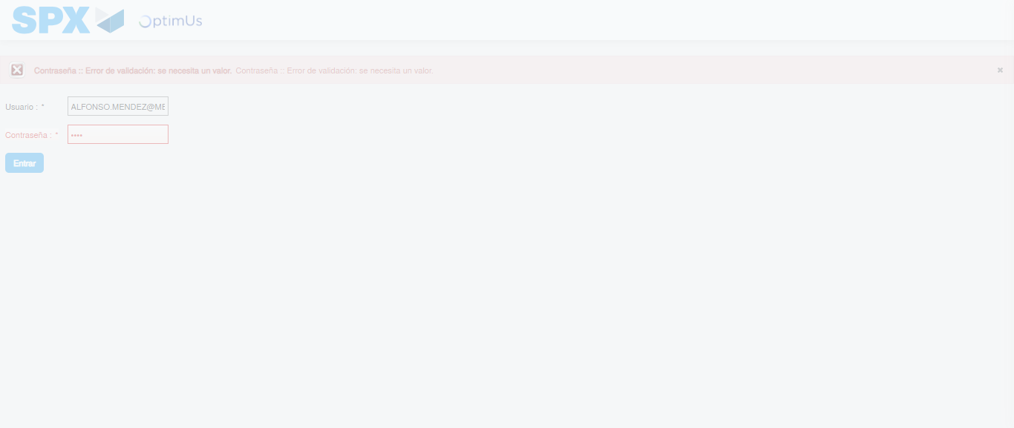Image file-name: QC_Testing-tc006_SPX_Dev5_Crear_Requisicion_Spot_Tipo_Cobro_Proyect_Urgent-1783374869841

Step 2 - Select to UEN and Access to Spot Buy Requisitions : UEN Correctly selected and Correct access
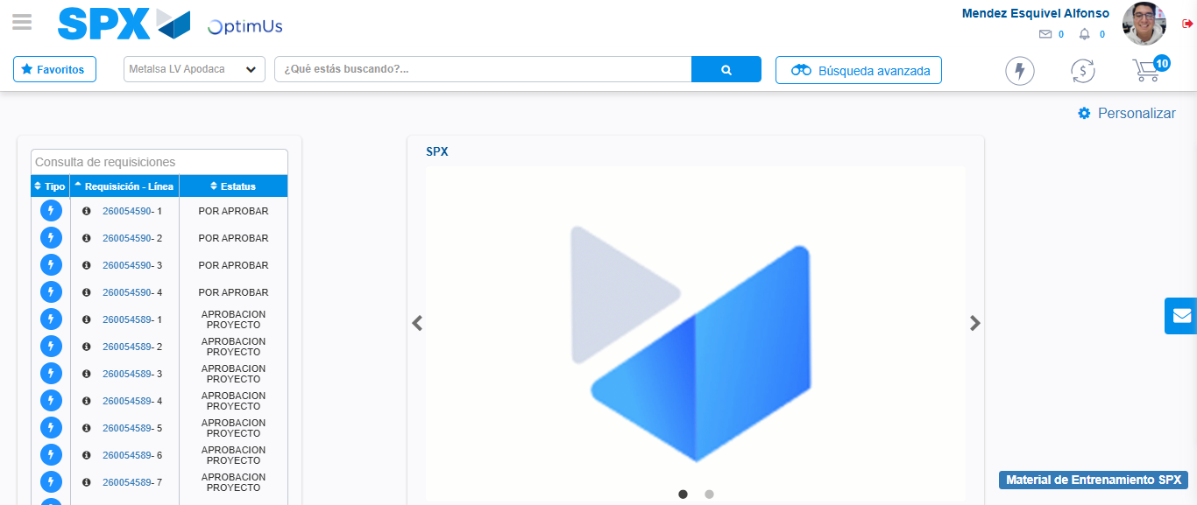Image file-name: QC_Testing-tc006_SPX_Dev5_Crear_Requisicion_Spot_Tipo_Cobro_Proyect_Urgent-1783374896294

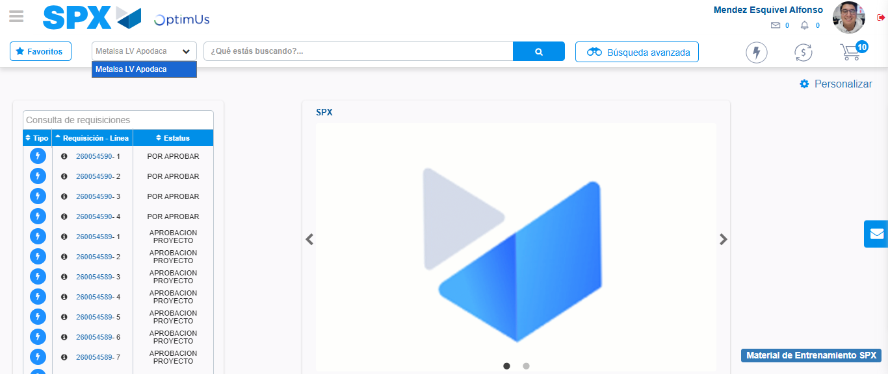Image file-name: QC_Testing-tc006_SPX_Dev5_Crear_Requisicion_Spot_Tipo_Cobro_Proyect_Urgent-1783374898846

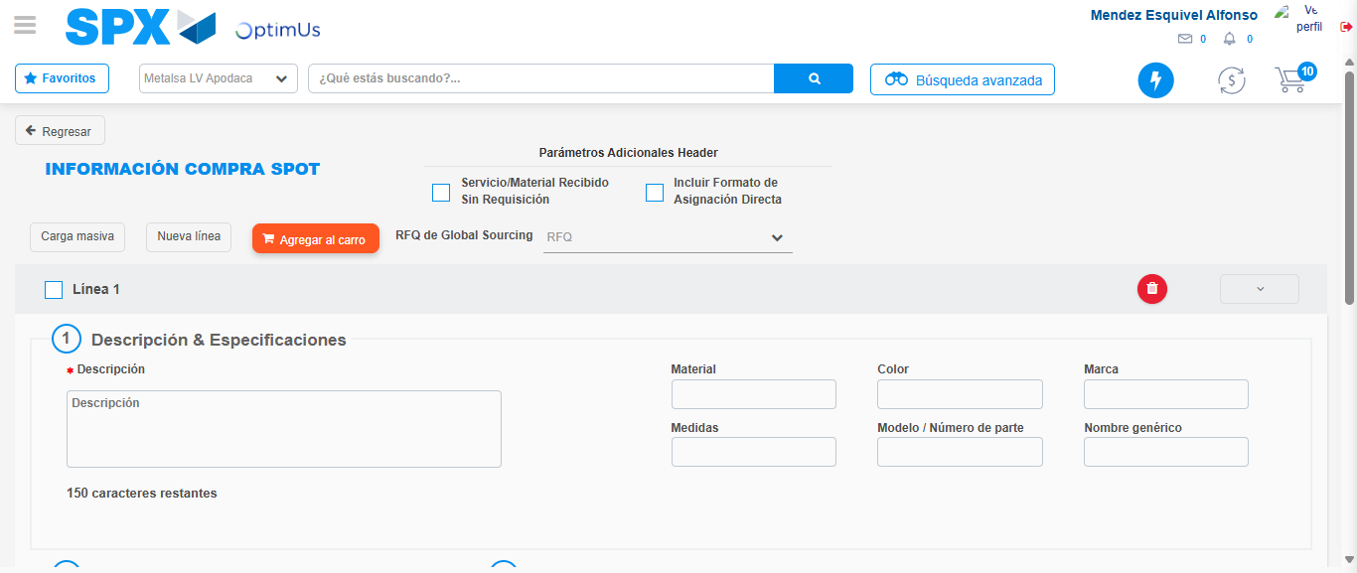Image file-name: QC_Testing-tc006_SPX_Dev5_Crear_Requisicion_Spot_Tipo_Cobro_Proyect_Urgent-1783374919002

Step 3 - Data Capture Spot Buy Requisition: Data captured correctly
Image file-name: QC_Testing-tc006_SPX_Dev5_Crear_Requisicion_Spot_Tipo_Cobro_Proyect_Urgent-1783374919223

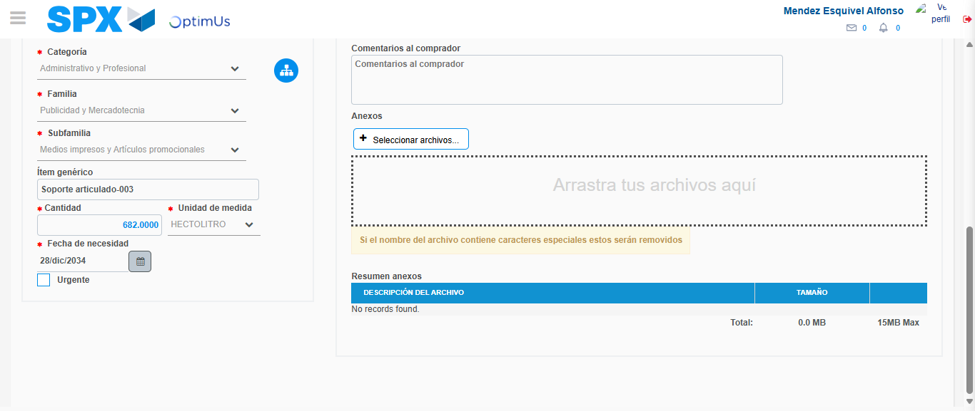Image file-name: QC_Testing-tc006_SPX_Dev5_Crear_Requisicion_Spot_Tipo_Cobro_Proyect_Urgent-1783374929140

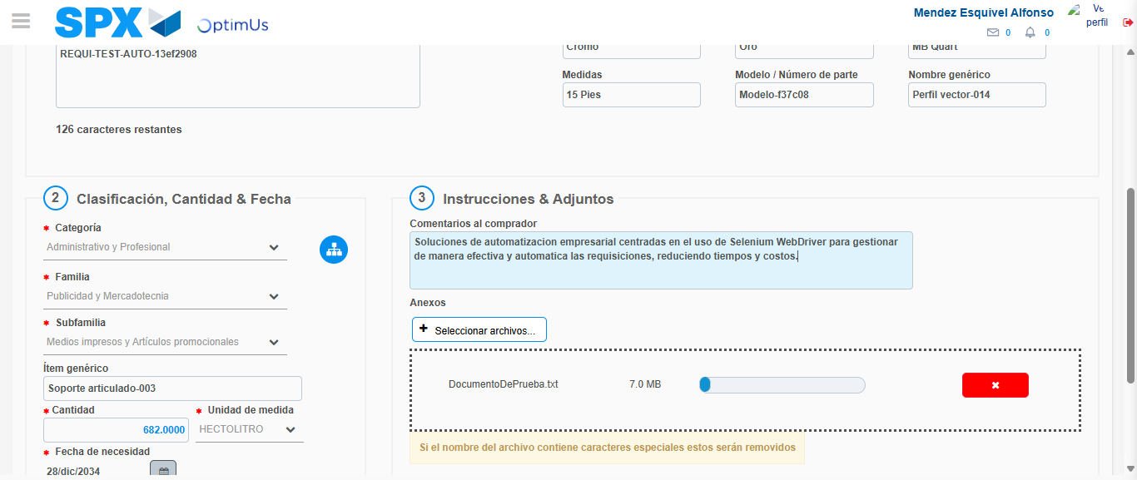Image file-name: QC_Testing-tc006_SPX_Dev5_Crear_Requisicion_Spot_Tipo_Cobro_Proyect_Urgent-1783374929873

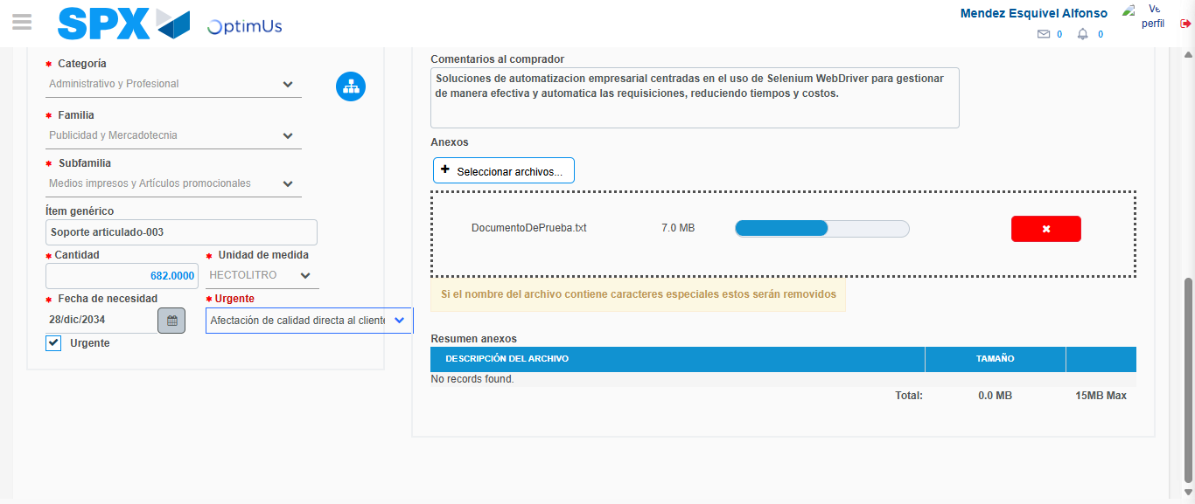Image file-name: QC_Testing-tc006_SPX_Dev5_Crear_Requisicion_Spot_Tipo_Cobro_Proyect_Urgent-1783374933638

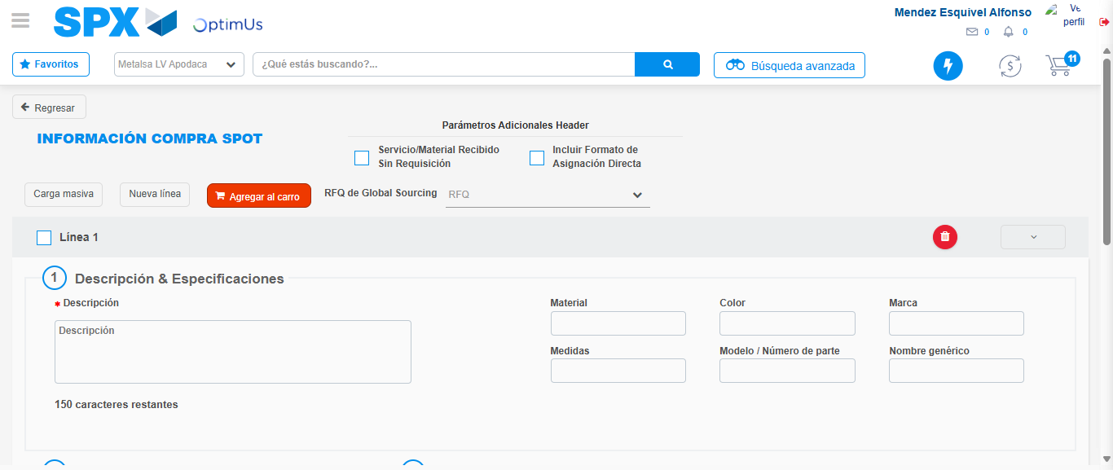Image file-name: QC_Testing-tc006_SPX_Dev5_Crear_Requisicion_Spot_Tipo_Cobro_Proyect_Urgent-1783374939156

Step 7 - Return to Main Page SPX : Return to Main Page SPX
Image file-name: QC_Testing-tc006_SPX_Dev5_Crear_Requisicion_Spot_Tipo_Cobro_Proyect_Urgent-1783374896294

Image file-name: QC_Testing-tc006_SPX_Dev5_Crear_Requisicion_Spot_Tipo_Cobro_Proyect_Urgent-1783374898846

Image file-name: QC_Testing-tc006_SPX_Dev5_Crear_Requisicion_Spot_Tipo_Cobro_Proyect_Urgent-1783374919002

Image file-name: QC_Testing-tc006_SPX_Dev5_Crear_Requisicion_Spot_Tipo_Cobro_Proyect_Urgent-1783374941392

Image file-name: QC_Testing-tc006_SPX_Dev5_Crear_Requisicion_Spot_Tipo_Cobro_Proyect_Urgent-1783374941544

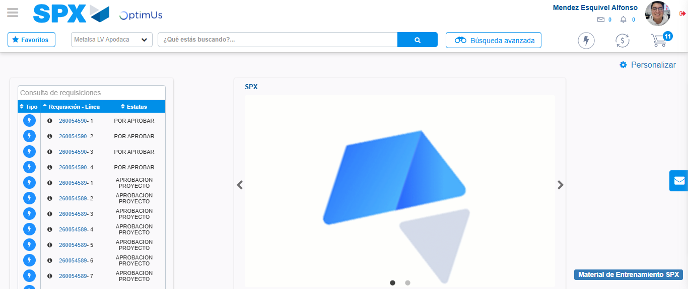Image file-name: QC_Testing-tc006_SPX_Dev5_Crear_Requisicion_Spot_Tipo_Cobro_Proyect_Urgent-1783374962549

Step 8 - Log Out : Log Out SPX
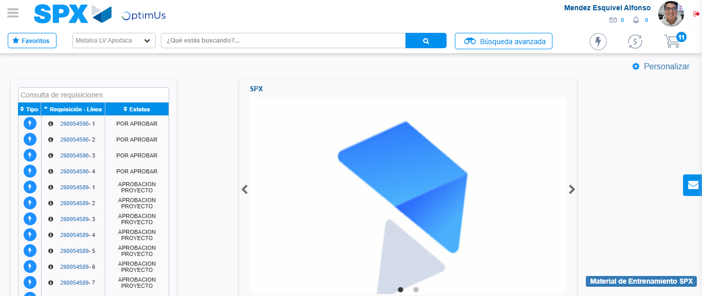Image file-name: QC_Testing-tc006_SPX_Dev5_Crear_Requisicion_Spot_Tipo_Cobro_Proyect_Urgent-1783374962782

